ICANN DNSO Registrar Constituency Proposal Draft

Inter-Registrar Domain Name Transfers:

Principles and Processes for Gaining and Losing Registrars

input.doc

9/19/2001 1:51 PM

Prepared by:
Elana Broitman (ebroitman@register.com),
Ross Wm. Rader (ross@tucows.com)

Inter-Registrar Domain Name Transfers:

Principles and Processes for Gaining and Losing Registrars

input.doc
9/19/2001 1:51 PM

Table of Contents
Summary 3
Issues 4
Gaining Registrar Processes 7
Gaining Registrar Processes Narrative 8
Losing Registrar Processes 12
Losing Registrar Processes Narrative 13
Losing Registrar Redress 14

Summary

- Exhibit B of the Registrar-Registry Agreement ("RRA") provides a general framework to govern the transfer of SLD Sponsorship between Registrars. In the interest of fostering an environment that promotes consumer confidence and facilitates such transfers between ICANN accredited Registrars, the ICANN DNSO Registrars Constituency proposes that member Registrars voluntarily adopt the following proposal that outlines a set of standard processes by which;

  - Gaining Registrars would obtain reliable authorization from appropriate authorities of transfer requests, and

  - Losing Registrars would authorize the transfer of such domain names in the absence of confirmation to the Losing Registrar by the Registered Name holder or an individual with the apparent authority to legally bind the Registered Name holder.

  - Inter-registrar domain name transfers become transactions predicated on trust and an assumed lack of malfeasance on behalf of any party to the transaction.

This document allows for variations in the implementation of these standards, as long as the prescribed minimum standards are complied with. This document furthermore provides for processes for a Losing Registrar to verify the Gaining Registrars' compliance with these minimum standards.

This document, while not an IETF draft, is offered in accordance with, and subject to, the terms of section 10 of RFC 2026.

Issues

- The drafting committee explored a number of issues that were deemed outside the scope of this document for a variety of reasons.

It was recognized that the Registrar Constituency might wish to consider, at a future date;

  - the adoption of an amendment to this proposal that would provide for a standard that ensured that the Gaining Registrar would indemnify the Losing Registrar against legal recourse in the case of a reversal of transfer due to improper authorization of the transaction, and;

  - the implications of Registrar Lock processes in use by various Registrars and how they may affect the application of this document, and;

  - the creation of a process that would cause the Gaining Registrar to fully cooperate with, and bear the direct costs of, transferring domain names back to the Losing Registrar in a case where it has been demonstrated that the Gaining Registrar did not act in accordance with the practices and processes contemplated by this document.

  - A requirement to authenticate or notarize some, or all, of the documentation procured by the Gaining Registrar throughout the transfer process.

These are complex issues that each require further study and analysis before an amendment to this document can be recommended.

Principles

- General Principles

  - Inter-registrar domain name transfers (IRDX) transactions MUST not be undertaken in conflict with ICANN or Registry contracts. If a conflict occurs, ICANN or Registry contracts MUST take precedent.

  - IRDX processes MUST allow Registered Name holders to transfer their domain name registrations between registrars provided that the Gaining Registrar's transfer process follows minimum standards and such transfer is not prohibited by ICANN or registry policies.

  - IRDX processes MUST prevent parties not authorized by the Registered Name holder, pursuant to Registry and ICANN contracts, from completing an IRDX transaction.

  - IRDX processes MUST require Gaining Registrars to maintain reliable evidence of express authorization by an individual or entity that possesses apparent authority to legally bind the Registered Name holder.

  - IRDX transactions MUST be undertaken in a manner that engenders Registered Name holder confidence.

  - IRDX transactions SHOULD, wherever possible, be implemented using existing protocols and standards.

  - IRDX transactions MUST withstand reasonable inspection before, during and after the transaction has occurred.

  - IRDX processes MUST maintain minimum standards of consumer protection, while taking into account the legal, linguistic and cultural differences of the domain name registration market, registrars, and Registered Name holders.

  - IRDX processes MUST NOT place undue burden on the Registered Name holder, registrar or registry.

  - IRDX processes SHOULD be automated.

  - Specific implementations of IRDX processes MUST remain at the discretion of the implementing party.

  - IRDX process implementation and administration MUST be the responsibility of the Gaining Registrar.

  - IRDX process implementation and administration MUST NOT allow for undue influence or manipulation by the losing registrar or any other third party.

  - IRDX transactions MUST only be undertaken at the request of the Registered Name holder or someone with the apparent authority to act on behalf of the Registered Name holder.

  - Registered Name holders, or an individual with the apparent authority to legally bind the Registered Name holder, MUST be provided the capability to verify their intention to complete an IRDX transaction as part of the IRDX process.

  - IRDX processes MUST be as clear and concise as possible in order to avoid confusing Registered Name holders or other stakeholders.

  - IRDX processes MUST be subject to verification by the Losing and Gaining Registrar.

  - IRDX transactions SHOULD be denied by the Losing Registrar if the Gaining Registrar has not implemented the minimum standards and practices contemplated by this document or the relevant Registry Agreement

Gaining Registrar Processes

- Diagram 4.0
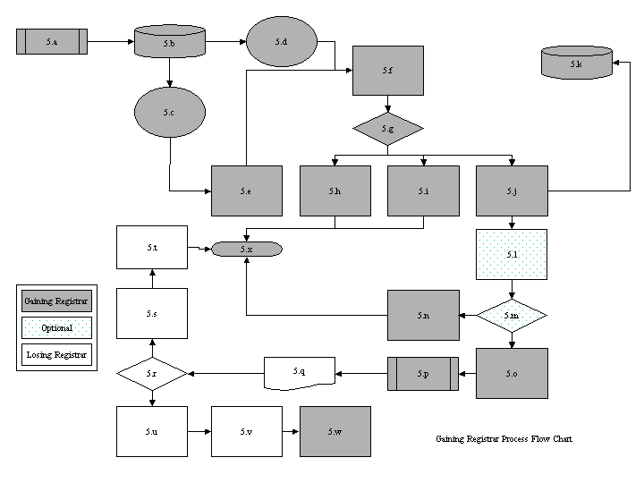

Gaining Registrar Processes Narrative

- The following section is intended to act as a descriptive guide to the processes outlined in Diagram 4.0.

  - Entity Files Transfer Request - The entity in question may be any of the following: the Registered Name holder, the administrative contact, or someone authorized to act on the Registered Name holder's behalf. This transfer request may be filed through virtually any means including telephone, email, web, etc. It is not mandatory at this point that the entity be verified as having the authority to initiate a change in SLD Sponsorship.

  - Gaining Registrar retrieves Whois record for domain from Losing Registrar and stores output - This could be accomplished through any Whois service as long as the output is an accurate representation of the Losing Registrar's data at the time of capture by the Gaining Registrar.

  - Whois Data is invalid - This covers a number of conditions including invalid or out of date email addresses or other contact information

  - Whois Data is valid - Validity is solely determined when the Gaining Registrar can reasonably conclude that the Whois data provided by the Losing Registrar is correct. (e.g. - email sent to the admin contact doesn't bounce).

  - Gaining Registrar attempts to contact the Registered Name holder, or an individual with the apparent authority to legally bind the Registered Name holder, for manual authorization - This can be undertaken, especially in automated environments, when the primary contact data is incorrect (e.g. - email address) but other data elements are correct (e.g. - phone number). The Gaining Registrar should use all means at their disposal to contact the Registered Name holder, or an individual with the apparent authority to legally bind the Registered Name holder. If no response is available, the transfer request must not be honored and must necessarily fail.

  - The Registered Name holder is provided with means of verification - this may take many forms including simplified web forms or paperwork. The Gaining Registrar may choose to employ a means of verification not contemplated by this document as long as the means comply with this document, specifically the minimum standards of data acquisition and retention, in written or electronic form, as outlined in 5.k. The documentation that verifies the transaction is called the "Form of Authorization" (FOA). In all cases, the FOA must provide the Registered Name holder with clear instructions for approving or denying the request for authorization, the identity of the Gaining Registrar (and other parties to the transaction - e.g. resellers) and a concise statement describing the impact of the Registered Name holder's decision(s). This requirement is intended to ensure that the form of request employed by the Gaining Registrar is substantially administrative and informative in nature and clearly provided to the Registered Name holder for the purpose of verifying the intent of the Registered Name holder.

  - Customer decides intent - This is a decision point at which the Registered Name holder, or an individual with the apparent authority to legally bind the Registered Name holder must determine whether or not they wish to undertake the transfer request.

  - The Registered Name holder, or individual with the apparent authority to legally bind the Registered Name holder, denies authorization - Gaining Registrar does not continue the transaction.

  - No response is received from the Registered Name holder, or individual with the apparent authority to legally bind the Registered Name holder - Gaining Registrar does not continue the transaction. No Response is received from the Registered Name holder, or individual with apparent authority to bind the Registered Name holder, - Gaining Registrar does not continue with the transaction.

  - The Registered Name holder, or individual with the apparent authority to bind the Registered Name holder, verifies transfer request – Acquisition of the FOA must be undertaken in a manner that can be documented and cannot be reasonably intercepted, forged or otherwise duly influenced by third parties.

  - Transfer authorization record stored with transaction by Gaining Registrar - In addition to the minimum data acquisition and retention requirements specified by ICANN and the Registry to ensure the validity of transactions from an audit perspective, at least one of the following forms of data must be acquired and retained by the Gaining Registrar in a form that facilitates the inspection rights of the Losing Registrar;

    - Physical: Form of Authorization signed by the Registered Name holder or an individual who has the apparent authority to legally bind the Registered Name holder. Such authorization must make explicit reference to the domain name(s) being transferred. A signed master FOA separate from an electronic communication with the domain names in question is also acceptable, so long as this master FOA is signed by both an authorized representative of the Gaining Registrar and the Registered Name holder, or an individual who has the apparent authority to legally bind the Registered Name holder).

    - Electronic: A copy of the electronic communication sent to the Registered Name holder, or an individual who has the apparent authority to legally bind the Registered Name holder, by the Gaining Registrar notifying, in reply to or confirming the initial domain name transfer request described in 5.f. The language of the electronic communication;

        - must make clear to the Registered Name holder that its domain name is being transferred to the Gaining Registrar.
        - must be stored and saved with any applicable header information (date and time sent, sender, "to" addressee, etc.).

      - In case of an email authorization, the Gaining Registrar;

        - must retain a copy of the email to the Registered Name holder, or individual with the apparent authority to legally bind the Registered Name holder, confirming the transfer, and;
        - must maintain log files reflecting all system transactions with respect to the above transfers, including
          - email addresses that communications were sent to in obtaining authorization of the transfer,
          - the dates and times (mm/dd/yyyy hh:mm:ss) reflecting when;
            - the transfer was initially requested
            - the Gaining Registrar requested authorization
            - the FOA was obtained by the Gaining Registrar from the Registered Name holder or the individual who has the apparent authority to bind the Registered Name holder.
            - the Gaining Registrar filed the transfer of SLD Sponsorship request with the Registry,
            - a copy of the Whois information, as obtained from the Losing Registrars Whois database, for such domain name prior to the transfer for the domain name registration.

  - Transfer request sent to verification queue for inspection - An inspection queue should be used to re-verify the validity of the transfer request. See next description for full explanation.

  - Inspection - This may be a manual inspection, automated inspection or a combination of both. The purpose of this inspection is to ensure that obviously forged or suspect requests that have not been captured by previous processes are not forwarded to the registry for action. It is recommended that registrars implement both a manual and automated check. The automated portion should consist of a check against a blacklist of domains that must not be transferred.

  - Gaining Registrar does not approve transfer request - this can occur for any number of reasons, including suspicious transaction patterns.

  - Gaining Registrar approves transfer request - if the Gaining Registrar is satisfied with the apparent validity of the transaction, it may send the transfer request to the Registry for processing.

  - Transfer request sent to registry - this is undertaken exclusively via the RRP or EPP between the Gaining Registrar and the Registry.

  - Registry sends transfer announcement to Losing Registrar - implementation details are typically at the sole discretion of the registry in question. The Losing Registrar must adapt its systems and processes to the form and substance of this announcement in accordance with the minimum standards set forth in this document.

  - Losing Registrar minimum attribute check - Upon receipt of the transfer announcement sent by the registry, the Losing Registrar may undertake to check that the domain registration is not subject to one of the following conditions:

    - Situations described in the Domain Dispute Resolution Policy
    - A pending bankruptcy of the Registered Name holder
    - Dispute over the identity of the Registered Name holder
    - Request to transfer sponsorship occurs in the first 60 days after the initial registration with the Registrar.

  - Losing Registrar denies transfer - If the registration pending transfer possesses any, or any number of, the aforementioned attributes, the Losing Registrar may deny the transfer request in accordance with the relevant Registry Agreement.

  - Registry cancels transfer, notifies Gaining Registrar - self explanatory

  - Losing Registrar does nothing/acknowledges transfer - if the registration pending transfer does not possess the aforementioned attributes, then the Losing Registrar must authorize the transfer request, unless the Gaining Registrar did not follow the minimum procedures described herein. In such case, the losing registrar may deny the transfer according to the processes described in this document.

  - Registry undertakes transfer and notifies Gaining Registrar - self-explanatory.

  - Gaining Registrar notifies the Registered Name holder of successful transfer - self-explanatory. May be conducted by any number of means.

  - Transfer Fails – Self-explanatory.

Losing Registrar Processes

- Diagram 6.0
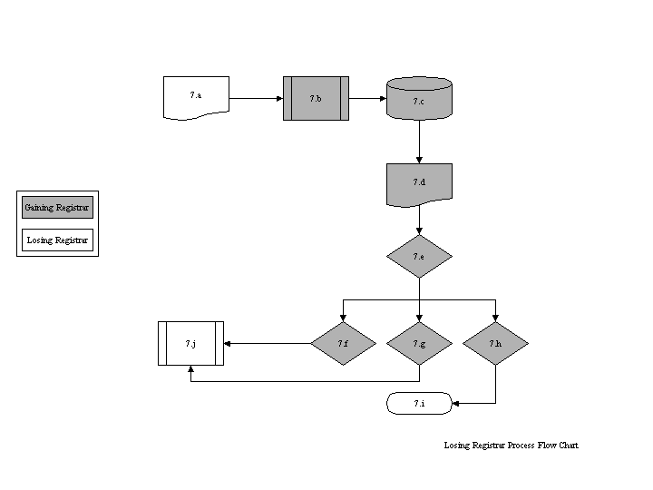

Losing Registrar Processes Narrative

- The following section is intended to act as a guide to the processes outlined in Diagram 6.0. This process may be utilized only for transfers to Gaining Registrars that follow the minimum consumer protection practices embodied in this document.

  - Registry Transfer Notification - Registry sends out notification of pending transfer to Losing Registrar.

  - Losing Registrar Receives notification, makes note of "domain_name" - Losing Registrar determines which domain name is pending transfer away.

  - Losing Registrar retrieves customer contact information from local database - Losing Registrar retrieves contact and customer details related to the domain pending transfer from its own records.

  - Notifies the Registered Name holder of pending request to transfer to another registrar - Losing Registrar notifies the Registered Name holder that its domain name is currently subject to a pending transfer away request.

  - Customer decides intent – The Registered Name holder reviews pending transfer request and determines whether or not he wishes to continue with the transfer request, or whether or not the originating transfer request is valid.

  - Do nothing/No Response - The Registered Name holder chooses not to, or does not respond to the notification of pending transfer.

  - Verify transfer request - The Registered Name holder explicitly approves the pending transfer request as being valid.

  - Deny transfer request - The Registered Name holder explicitly denies the pending transfer request as being valid.

  - Transfer Fails - The Losing Registrar files a non-acknowledgement of transfer request ("n'ack") with the Registry in case of 7.h by the Registered Name holder.

  - Registry Undertakes transfer - The Registry allows the pending transfer request to continue as being a valid and approved transfer request in case of step 7.f or 7.g by the Registered Name holder.

Losing Registrar Redress

- This section is describes the processes by which a Losing Registrar can seek clarification and redress in instances where the Losing Registrar has determined that the Gaining Registrar has not appropriately implemented the processes contemplated by this document.

Default Rule

- The Losing Registrar may deny a transfer request only when either of the following conditions are satisfied:

  - it receives an express objection from a Registered Name holder or an individual who has the apparent authority to legally bind the Registered Name Holder, or
  - the Gaining Registrar fails to comply with the minimum standards and practices contemplated by this document and/or the relevant Registry Agreement.

Minimum Standards

- The minimum standards mentioned in section 9 consist of the following:

  - The Gaining Registrar must retain, and produce pursuant to a reasonable request by a Losing Registrar, a written or electronic copy of reliable evidence of authorization by the Registered Name holder or an individual who has the apparent authority to legally bind the Registered Name holder. The Losing Registrar retains the right to verify the Registered Name holder's intent to transfer its domain name to the Gaining Registrar.

  - The verification of intent undertaken by the Losing Registrar must be undertaken in a manner consistent with the standards set forth in 5.f of the Gaining Registrars Process Narrative of this document, which describes the attributes of the FOA. Specifically, the form of the request employed by the Losing Registrar must provide the Registered Name holder with clear instructions for approving or denying the request for authorization and a concise declaration describing the impact of the Registered Name holder's decision(s).

  - This requirement is not intended to preclude the Losing Registrar from marketing to its existing customers through separate communications. This requirement is intended to ensure that the form of the request employed by the Losing Registrar is substantially administrative and informative in nature and clearly provided to the Registered Name holder for the purpose of verifying the intent of the Registered Name holder.

Losing Registrar’s Recourses

- If, at any time, the Losing Registrar wishes to verify the suitability of the documentation or data retained by, or the processes employed by, the Gaining Registrar, the Losing Registrar may request:

  - that the Gaining Registrar provide the Losing Registrar with a copy of the FOA as set forth in this document. Within ten (10) business days of receipt of the request by the Losing Registrar, the Gaining Registrar must provide the Losing Registrar with a copy of the FOA and any related supporting information.

  - pursuant to acquiring reasonable information that the Gaining Registrar may not be in compliance with the minimum standard and processes set forth in this document and pursuant to Exhibit B of the RRA, that the Gaining Registrar provide the Losing Registrar with evidence of compliance that specifically outlines the steps that the Gaining Registrar has taken to ensure compliance with the minimum standards and processes set forth in this document. The Gaining Registrar must provide this statement of compliance to the Losing Registrar within ten (10) business days of receiving the initial request from the Losing Registrar.

Obligations of the Gaining Registrar

- If the Gaining Registrar;

    - fails to respond to the request from the Losing Registrar, pursuant to 11.a, the Losing Registrar may choose not to honor all future transfer requests from the Gaining Registrar until such time that the Gaining Registrar can provide the Losing Registrar with a copy of the FOA as set forth in this document, or;

    - provides evidence of compliance not consistent with the minimum standards and processes contemplated by this document pursuant to 11.b, the Losing Registrar may choose not to honor all future transfer requests from the Gaining Registrar until such time that the Gaining Registrar can satisfy the Losing Registrar that they have adopted the minimum standards and processes contemplated by this document.

Losing Registrar’s Statement of Exception

- If the Losing Registrar chooses not to honor all transfer requests from the Gaining Registrar pursuant to section 12, the Losing Registrar must provide the Gaining Registrar with a written statement describing the specific minimum standards and/or processes set forth in this document that the Gaining Registrar must comply with in order that the Losing Registrar may resume honoring transfer requests from the Gaining Registrar. This statement of exception should not include confidentiality clauses that restrict the right of either party to publicize the statement of exception.

Obligation to Resume Transfers

- At such time that the Gaining Registrar can reasonably demonstrate compliance with the written statement of exception, the Losing Registrar must immediately resume honoring requests from the Gaining Registrar.

Invoking The Benefits of the Process

- The Losing Registrar is allowed to decline the request to transfer
  - at any time after it has received the express objection, in the case contemplated by section 9a, or;
  - at any time it reasonably concludes that the Gaining Registrar consistently fails to comply with the requirements of sections 10, 11 and 12.

It was unclear by the drafting committee whether this step was necessary or not. It will be considered an optional condition unless the Registrar Constituency a) adopts an amendment at a future date, or b) the Registrar Constituency specifies otherwise during the comment period prior to the adoption of this document.

