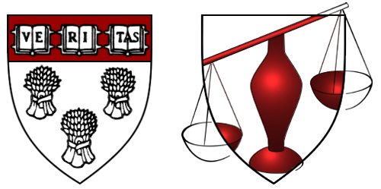
THE BERKMAN CENTER FOR INTERNET & SOCIETY
AT HARVARD LAW SCHOOL

1563 Massachusetts Avenue • Pound Hall 511 • Cambridge, Massachusetts 02138
+1 617.495.7547 • +1 617.495.7641 (fax) • http://cyber.law.harvard.edu • cyber@law.harvard.edu
Charles Nesson, Director
Eric F. Saltzman, Executive Director

August 15, 2000

Dear Colleague,

The Internet continues to generate a number of fascinating legal issues. Many of the cases involving the most novel and compelling questions do not generate financial recovery. Litigation timelines can overwhelm staff availability. Volunteer officers in non-profit organizations are often stretched by multiple demands. The Berkman Center hopes to help you respond to Internet-related cases by providing a standing pool of law students that can be tapped for pro bono assistance as contingencies arise.

To do so, the Berkman Center is establishing a clinical program in cyberlaw. Operating in conjunction with Internet-related courses taught by our faculty, such as Jonathan Zittrain’s Internet & Society, the program will offer practical experience to our second- and third-year law students.

Each student must work a minimum of 9 hours on client matters each week in order to receive degree credit. Participants may not receive payment for their work, nor may they be used on fee-generating cases. They can be placed onsite as externs (for Boston-area organizations) or they can work here at the Berkman Center and submit material electronically. Although a commitment to a particular student for an entire term is preferred, shorter assignments for the pool, such as the preparation of an appellate brief, will also be welcome.

Clinical placements do carry a supervisory burden, including mid-term and final evaluation interviews. With an understanding of the time constraints faced by busy practitioners, it will be my pleasure to assist you as much as possible in the performance of this obligation.

If you think the program might be of value to you, please let me know as soon as possible. Our program begins on September 11 and ends Dec. 10, 2000. If you have any questions, contact me directly. I hope we can be of mutual assistance and I look forward to productive and beneficial experiences.

Regards,

Diane Cabell
Clinical Program in Cyberlaw
cabell@cyber.law.harvard.edu

